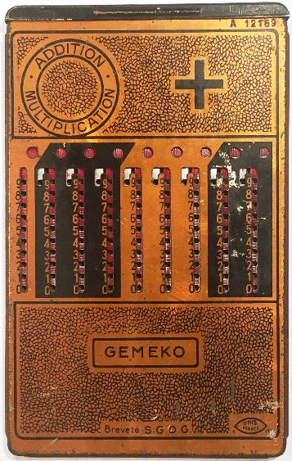

GEMEKO

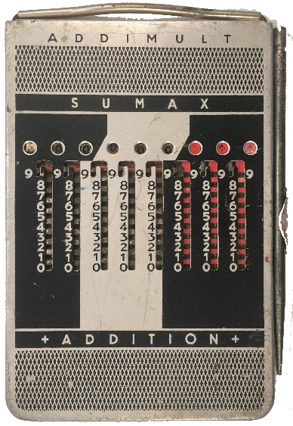

Addimult sumax

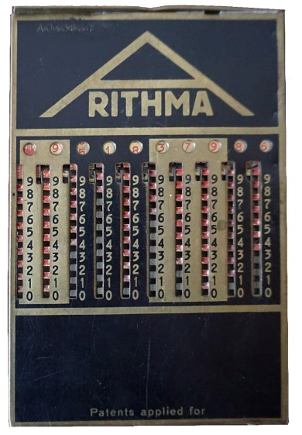

Addiator Arithma A (1)

**26 New Items in 3.1 (2022)**

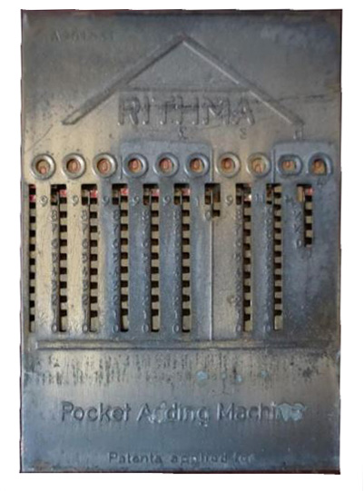

Addiator Arithma A Sterling

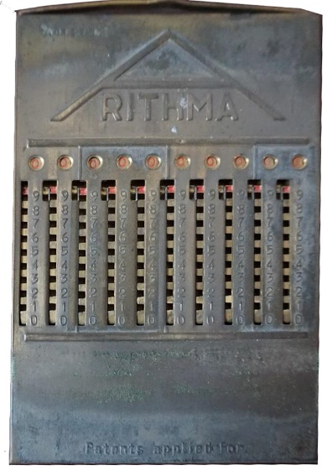

Addiator Arithma A (2)

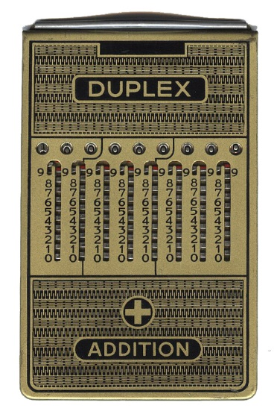

Addiator Duplex (Weak currency)

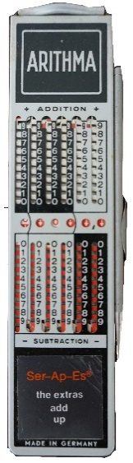

Addiator Arithma Ser-Ap-Es

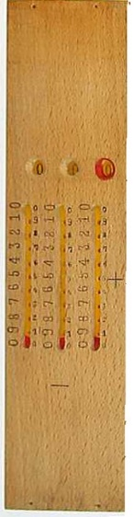

Controleur des Calculs (1a)

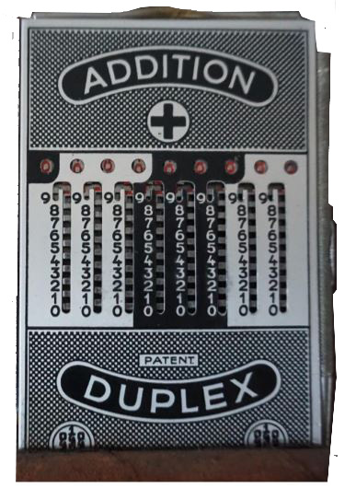

Addiator Duplex

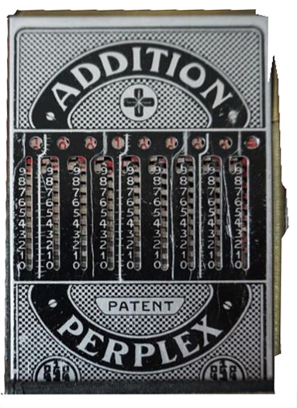

Addiator Duplex

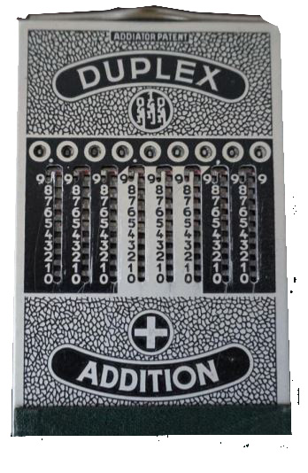

Addiator Duplex

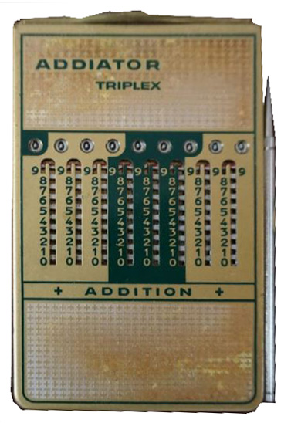

Addiator Triplex

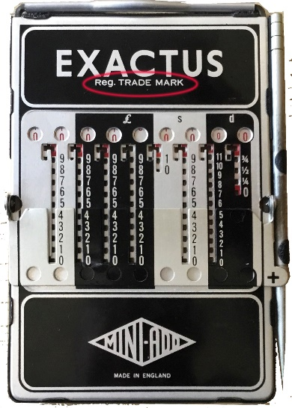

Exactus (Reg. Trade Mark)

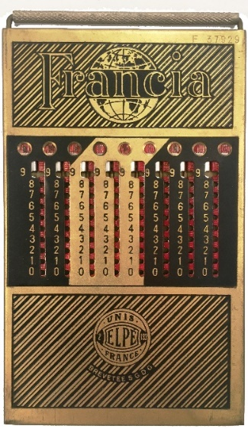

Francia (3-3-3)

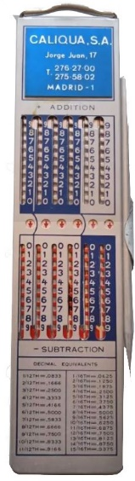

Caliqua S.A. (Kingson)

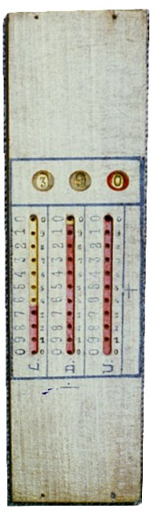

Controleur des Calculs (1b)

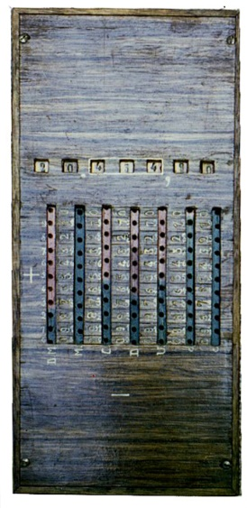

Controleur des Calculs (2)

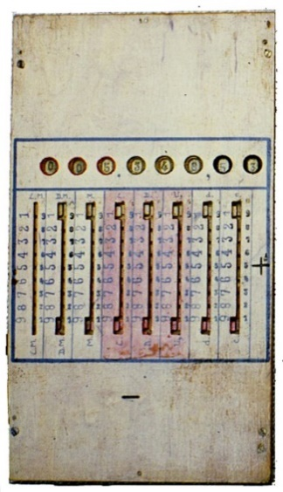

Controleur des Calculs (3)

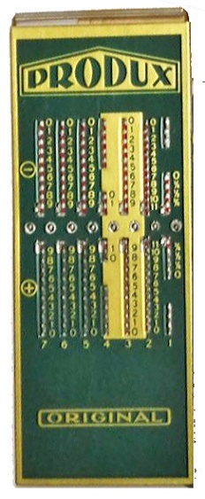

Produx Original Sterling

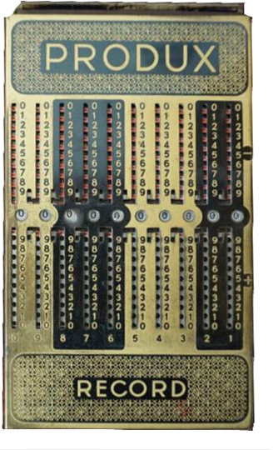

Produx Record (Gold)

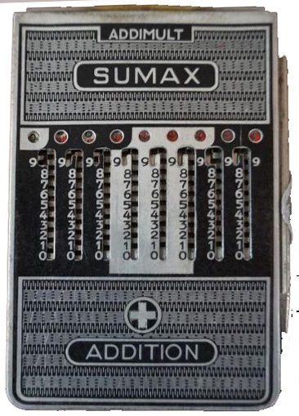

Addimult Sumax

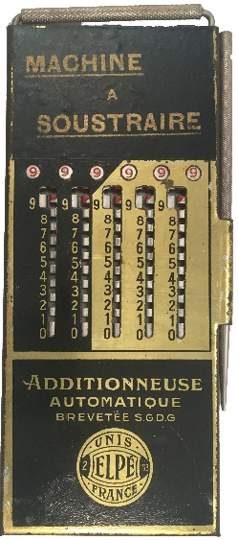

Machine a Soustraire

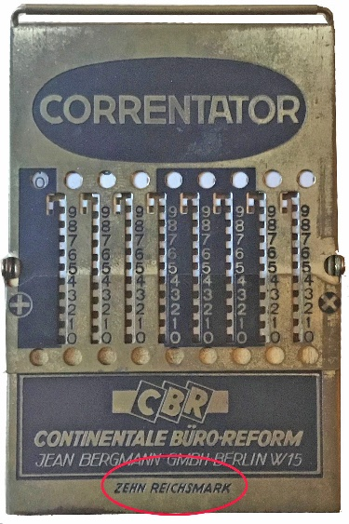

Correntator CBR

Zehn Reichsmark

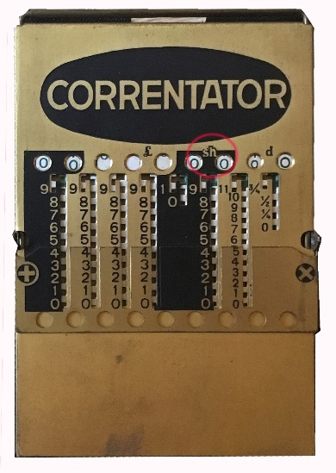

Correntator (shilling=sh)

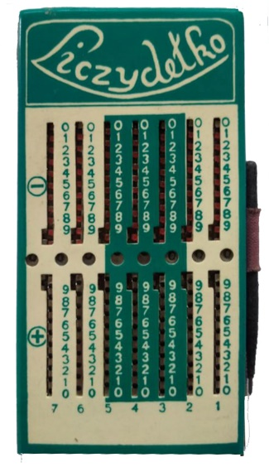

Liczydelko

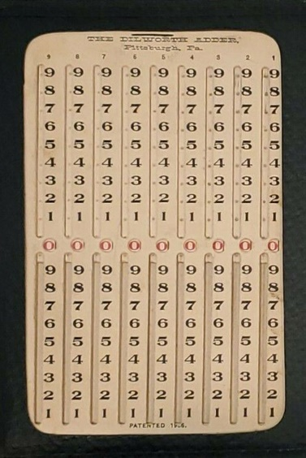

Dilworth Adder